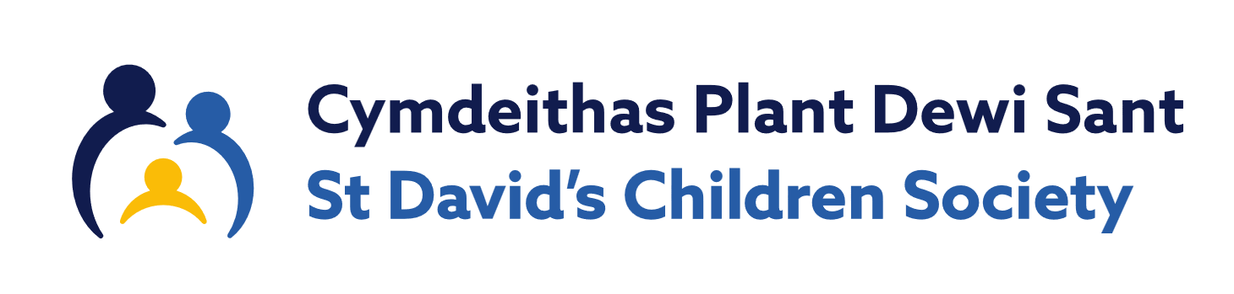
Children and Young People Support Worker | Swyddog Plant a Phobl Ifanc
St David’s Children Society | Cymdeithas Plant Dewi Sant
18 hours per week (including evenings and weekends).  Fixed term for 3 years | 18 awr yr wythnos (gan gynnwys gyda'r nos a phenwythnosau)  Cyfnod penodol am 3 blynedd
Salary £13,690-£14,606 (FTE £28,142 - £30,024) per annum  [SCP Band 11-15] | Cyflog £13,690-£14,606 (FTE £28,142 - £30,024) per annum  [Band SCP 11-15]
Cardiff, Wales | Caerdydd, Cymru
Job Summary:  We are looking for a compassionate and proactive Support Worker who can offer support to children and young people who have been adopted or are currently living in foster care. This role involves working directly with children and young people and their families both one-to-one and in groups. You will also provide practical support, information and advice. The role will include working collaboratively with colleagues and external professionals and ensuring that safeguarding responsibilities are met.  Key Responsibilities:  - Visit child/young person and their families at home or in the community to provide one-to-one support.  - Build trusting relationships to support emotional wellbeing and development.  - Facilitate age-appropriate peer group activities.  - Work with parents/carers to offer practical advice and strategies.  - Collaborate with social workers and other professionals to ensure coordinated support.  - Participate in safeguarding processes and contribute to professional meetings and reviews when required.  - Maintain accurate records, plans, and evaluations.  Requirements:  - Experience working with children and families, particularly those who are adopted or in care.  - Understanding of trauma-informed and attachment-aware practices (or willingness to learn)  - Strong communication and partnership working skills.  - Ability to handle sensitive information and respond to safeguarding concerns appropriately.  - Full driving licence  - Willingness to travel and work flexibly, including evenings and weekends. | Crynodeb o'r swydd:  Rydym yn chwilio am Weithiwr Cymorth tosturiol a rhagweithiol a all gynnig cymorth i blant a phobl ifanc sydd wedi cael eu mabwysiadu neu sy'n byw mewn gofal maeth ar hyn o bryd. Mae'r rôl hon yn cynnwys gweithio'n uniongyrchol gyda phlant a phobl ifanc a'u teuluoedd, un-i-un ac mewn grwpiau. Byddwch hefyd yn darparu cefnogaeth, gwybodaeth a chyngor ymarferol. Bydd y rôl yn cynnwys cydweithio â chydweithwyr a gweithwyr proffesiynol allanol a sicrhau bod cyfrifoldebau diogelu yn cael eu bodloni.  Cyfrifoldebau Allweddol:  - Ymweld â phlentyn/person ifanc a'u teuluoedd gartref neu yn y gymuned i ddarparu cymorth un-i-un.  - Adeiladu perthynas ymddiriedol i gefnogi lles a datblygiad emosiynol.  - Hwyluso gweithgareddau grŵp cyfoedion sy'n briodol i oedran.  - Gweithio gyda rhieni/gofalwyr i gynnig cyngor a strategaethau ymarferol.  - Cydweithio â gweithwyr cymdeithasol a gweithwyr proffesiynol eraill i sicrhau cefnogaeth gydgysylltiedig.  - Cymryd rhan mewn prosesau diogelu a chyfrannu at gyfarfodydd ac adolygiadau proffesiynol pan fo angen.  - Cynnal cofnodion, cynlluniau a gwerthusiadau cywir.  Gofynion:  - Profiad o weithio gyda phlant a theuluoedd, yn enwedig y rhai sy'n cael eu mabwysiadu neu mewn gofal.  - Dealltwriaeth o arferion sy'n ymwneud o drawma ac ymlyniad (neu barodrwydd i ddysgu)  - Sgiliau cyfathrebu cryf a gweithio mewn partneriaeth.  - Y gallu i drin gwybodaeth sensitif ac ymateb i bryderon diogelu yn briodol.  - Trwydded yrru lawn  - Parodrwydd i deithio a gweithio'n hyblyg, gan gynnwys gyda'r nos a'r penwythnosau.
Contact  Visit our website www.stdavidsadoptionservice.org/work-with-us or to request a recruitment pack please contact 02920 667007 or email hr@stdavidscs.org | Cyswllt  Ymwelwch a’n gwefan www.stdavidsadoptionservice.org/gweithio-gyda-ni neu i ofyn am becyn recriwtio cais ffoniwch 02920 667007 neu anfonwch e-bost i hr@stdavidscs.org
For an informal conversation about this role please contact, Coralie Merchant on coralie@stdavidscs.org. | Am sgwrs anffurfiol am y rôl hon, cysylltwch â Coralie Merchant ar coralie@stdavidscs.org.
Closing Date: 11.59pm on 19th November 2025 | Dyddiad Cau: 11.59pm ar 19 Tachwedd 2025
Interview Date: Tuesday 2nd December 2025 | Dyddiad cyfweld: Dydd Mawrth 2^{il} Rhagfyr 2025
St David’s Children Society is registered as a charity with the Charity Commission for England and Wales (Registration No: 509163) and a company limited by Guarantee (Registered Cardiff 1546688)   | Mae Cymdeithas Plant Dewi Sant wedi ei chofrestru fel elusen gyda Chomisiwn Elusennau Cymru a Lloegr (Rhif Cofrestru: 509163) a chwmni cyfyngedig drwy Warant (Cofrestredig Caerdydd 1546688)  