 |  |  |  | 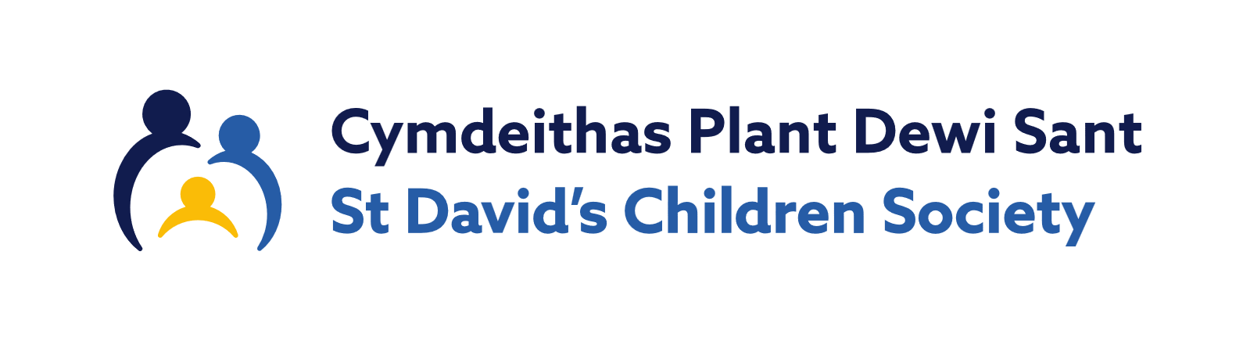
Application for Employment
St David’s Children Society is registered as a charity with the Charity Commission for England and Wales (Registration No: 509163) and a company limited by Guarantee (Registered Cardiff 1546688).
St David’s Adoption Service is the brand name of the St David’s Children Society’s adoption service. The Association for Fostering and Adoption (AFA) Cymru is the brand name of the St David’s Children Society’s advice, training, and consultancy service.

St David’s requires the information requested in this form for recruitment purposes. This information is required to inform decision-making for effective recruitment and is a legitimate interest under General Data Protection (GDPR). This form will be stored securely in locked cabinets and security protected computers for a minimum period of 12 months. Information will be shared internally with staff involved in the recruitment process and will not be passed on to a third party without permission.
Official Use only:
Post Applied for:
Service:
PERSONAL INFORMATION
Surname
Forenames
Address
Postcode
Telephone
Email
SCW Registration No.
(if applicable)
Where did you see this job advertised? |  | ☐ Indeed |  | ☐ Coram BAAF |  |  | ☐ Jobs Wales |  | ☐ Recruit3 |  | ☐ Charity Job Finder
 |  | ☐ Other (Please state)
MOST RECENT EMPLOYMENT
Employer
Job Title
Date of Appointment |  | Date started: |  |  |  |  |  | End date:  (if applicable)
Current Salary
Notice Period
Please describe your main duties and responsibilities
EMPLOYMENT HISTORY
Please give full details of your employment history (including voluntary and other relevant experience) you held prior to your present post, starting with the most recent first.
Employer or Organisation |  | From | To |  | Job Title |  |  |  |  | Responsibilities
 |  | Mth/Yr | Mth/Yr
EDUCATIONAL AND PROFESSIONAL QUALIFICATIONS
Please list all academic, vocational, professional, and technical qualifications in chronological order of award. Where it is not obvious, please identify the awarding body:
School/College/University |  | From | To |  | Qualification
 |  | Mth/Yr | Mth/Yr
Please list any in-service training undertaken over the past 3 years:
REFERENCES
Please state the names and addresses of three people from whom references may be obtained: a current or most recent employer, a previous employer and a personal reference. In the absence of previous employment experience, a reference from your last place of full-time education will be a suitable alternative.
Name of Referee 1

Address (including postcode)

Telephone number/s

Email

Relationship to applicant

How long acquainted

Can this reference be taken up prior to interview? |  |  |  |  |  |  |  |  | ☐ Yes ☐ No
Please indicate the capacity in which you know this person |  |  |  |  |  |  |  |  | ☐ Professional ☐ Personal
Name of Referee 2

Address (including postcode)

Telephone number/s

Email

Relationship to applicant

How long acquainted

Can this reference be taken up prior to interview? |  |  |  |  |  |  |  |  | ☐ Yes ☐ No
Please indicate the capacity in which you know this person |  |  |  |  |  |  |  |  | ☐ Professional ☐ Personal
Name of Referee 3

Address (including postcode)

Telephone number/s

Email

Relationship to applicant

How long acquainted

Can this reference be taken up prior to interview? |  |  |  |  |  |  |  |  | ☐ Yes ☐ No
Please indicate the capacity in which you know this person |  |  |  |  |  |  |  |  | ☐ Professional ☐ Personal
GENERAL
Do you require a work permit or similar to legally work in the UK? |  |  |  |  |  |  |  |  | ☐ Yes  ☐ No
Do you hold a current driving licence? |  |  |  |  |  |  |  |  | ☐ Yes  ☐ No
Would you have use of a car for the purpose of this post? |  |  |  |  |  |  |  |  | ☐ Yes  ☐ No
Are you related to any member of the Agency’s governing body or staff?  If yes, please state relationship: |  |  |  |  |  |  |  |  | ☐ Yes  ☐ No
The post for which you are applying is considered exempt from the REHABILITATION OF OFFENDERS ACT 1974 s 4(2) by virtue of the REHABILITATION OF OFFENDERS ACT 1974 (EXEMPTIONS) ORDER 1975. Candidates are not entitled to withhold information about convictions which for other purposes are ‘spent’ and, in the event of employment, any failure to disclose such convictions could result in dismissal or disciplinary action.  Have you been convicted of any criminal offence?  If you have, please give details of all convictions (NB. this includes motoring convictions), dates of convictions and sentences imposed. |  |  |  |  |  |  |  |  | ☐ Yes  ☐ No
It is the policy of St. David’s to carry out a DBS check where it is appropriate for the post. This information will only be pursued with candidates whom the Agency wishes to appoint, and any information given will be treated in the strictest confidence.  - Are you subscribed to the DBS update service? (Only answer if having a DBS is a requirement of the post. Refer to the person specification for guidance.) |  |  |  |  |  |  |  |  | ☐ Yes  ☐ No
STATEMENT IN SUPPORT OF APPLICATION
Please evidence below how your experience meets the person specification criteria set out in the job description (continue on a separate sheet if necessary)
DATA PROTECTION ACT 2018 – CONSENT AND CERTIFICATION OF DETAILS
The information detailed in this application form and accompanying monitoring information, will be used to monitor the effectiveness of St David’s policies and practices, in particular its Equal Opportunities. This monitoring is for statistical purposes only and you will not be identifiable from this process.

Your personal details contained in the application form, may be used in the prevention and detection of fraud. Where this occurs, you will be identifiable. The information may be disclosed to the following third parties:

Government/Statutory Agencies
Law Enforcement Authorities

Giving false information will result in your application not being pursued or your contract being terminated, without notice, if you have already been appointed to the job.

Application forms of unsuccessful candidates will be destroyed after twelve months from the closing date for the post.

Declaration
I, (print name)
Consent to St David’s recording and processing the information detailed in this application form. I understand that this information may be used by St David’s in the undertaking of its business purposes and my consent is conditional upon St David’s complying with their obligations under the Data Protection Act 2018.

I also confirm that the information contained in this application form is complete and correct and that inaccurate or misleading statements may be sufficient for St David’s to cancel any agreement or contract made, or my being dismissed without notice.

Signature
Date
Please return the completed form to:
Email: HR@stdavidscs.org
Post: HR, St David’s Children Society, Lambourne House, Lambourne Crescent, Llanishen Business Park, Cardiff, CF14 5GL.

Should you have any additional enquiries please contact
Email: HR@stdavidscs.org
Tel No. 029 2066 7007

